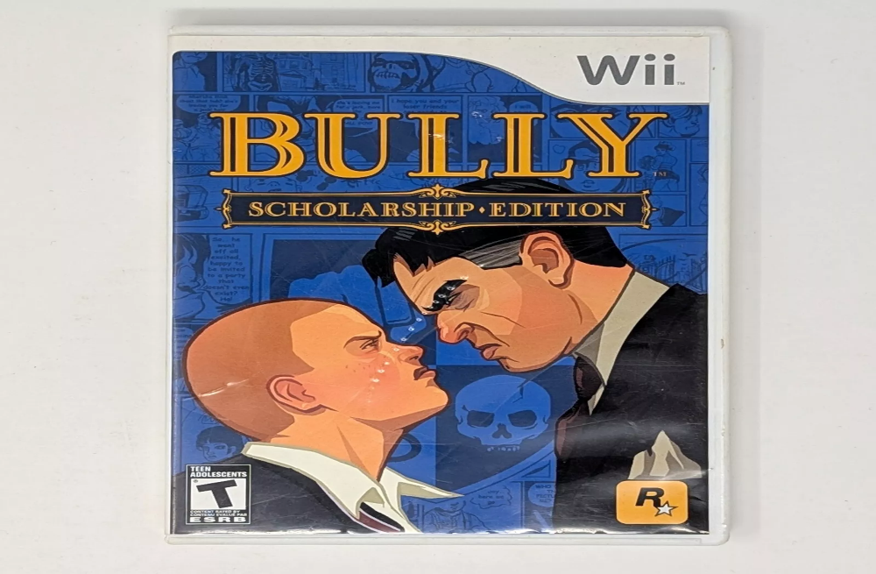

Bully: Scholarship Edition:

**1️. Unique School-Based Open World**

Set in **Bullworth Academy**, a **boarding school** environment with classrooms, dorms, and a nearby town to explore.

**2️. Engaging Story & Social Hierarchies**

Play as **Jimmy Hopkins**, a rebellious teenager dealing with **cliques like jocks, nerds, greasers, and preppies** while trying to gain control over the school.

**3️. Fun Activities & Mini-Games**

Attend **classes (Math, English, Science, Gym, etc.)**, pull pranks, ride bikes, play arcade games, and participate in **boxing matches**.

**4️.Expanded Content in Scholarship Edition**

Includes **8 new missions, 4 new classes (Biology, Math, Music, Geography),** and **new unlockables** with a **multiplayer mode**.

**5️.Cult Following & Demand for a Sequel**

Despite its **success and popularity**, Rockstar has not released a sequel, but fans still hope for **Bully 2**.